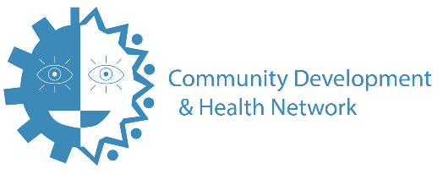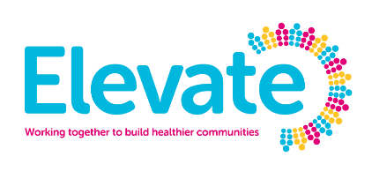

Elevate Mentoring & Grants Programme

Community Development & Health Inequalities

Thank you for your interest in the Elevate Mentoring & Grants Programme.

Before completing this form please ensure you have read the Guidance Notes. If successful, your staff and/or volunteers should have sufficient time available to take part in the Elevate Mentoring and Grants Programme which will run from October 2019 to February 2020.

Your application will be scored based on the answers you provide to the questions in this application form. The maximum score is 50. Please see Guidance Notes for more information.

The deadline for applications is 4pm on Friday, 13th September 2019 and you will be informed by Tuesday, 24th September 2019 whether or not you have secured a place on the programme. Thank you and good luck!

Completed applications should be e-mailed to catherinemurnin@cdhn.org or posted (to arrive no later than 4pm on Friday, 13th February) to CDHN, 30a Mill Street, Newry, County Down, BT34 1EY

For any queries please contact Catherine Murnin, Elevate Programme Manager
email catherinemurnin@chdn.org or call 028 3026 4606 mobile 07538 646 745

Application Form – Mentoring & Grants Programme
(Please refer to Guidance Notes before completing)

Your Organisation’s Name

______________________________________________________________________________

Type of organisation (applicants must be Charities, Social Enterprises or other Not-for-Profit Organisations)

______________________________________________________________________________

Company registration number ____________________ Charity number _________________
Address (including postcode)
______________________________________________________________________________

______________________________________________________________________________

Contact details for Application Form

Name_________________________________________________________________________

Email Address __________________________________________________________________

Telephone Number(s) ___________________________________________________________
Position within the Organisation __________________________________________________

Application Form continued (please refer to Guidance Notes for each question)

Q1. What does your organisation do? (400 words maximum) - for information only, this question will not be scored

Q2. How has your work made a difference in your community? How have you measured this difference? (300 words maximum ) Maximum Score: 10

Q3. What health inequalities exist in your community and why do you think they exist? (300 word maximum) Maximum Score: 10

Q4. What would you like to do to reduce these health inequalities? (300 word maximum) Maximum score: 10

Q5

(a) What positive change do you want to see for your organisation through your participation in the Mentoring and Grants Programme?

(b) What impact do you think you could have in your community by focusing on the health inequality you have highlighted in Q4? (400 words maximum) Maximum Score: 20

Please check the points below and confirm that you are able to meet these requirements:

- Our Board/Committee is aware of this application and is committed to supporting our team both through the process and in delivering the solution identified
- We have identified individuals connected with our organisation (staff members, volunteers, board members or beneficiaries) who are able to contribute the necessary time, both in attending the meetings and events outlined in the Guidance Notes
- We can provide relevant documentation including our Constitution and Accounts information
- We have an active bank account for the organisation applying to this programme
- We understand that we must attend workshops and adhere to all reporting and monitoring requirements under the mentoring and grants programme

I confirm we can meet the above requirements

Print Name _____________________ Signature ________________________ Date ________

