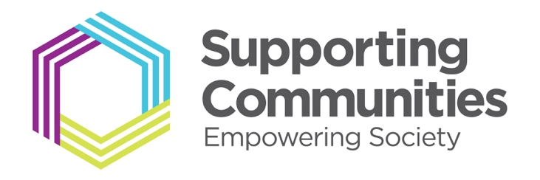

June 2019

Board Members Wanted

Supporting Communities is seeking additional new Board Members to ensure we have the capacity and skills to oversee the next phase of our work and who can help shape our charity’s future success.

We are looking for members who share our passion for community participation, active citizenship, and social impact as we realise our vision of creating engaged, confident, sustainable and inclusive communities in Northern Ireland.

New members with experience and skills in the fields of law and finance would be particularly welcome. We are also keen to welcome applicants from BME groups.
The roles are unpaid voluntary positions. Reasonable expenses are paid.

Our Board meet 5 times a year and attendance at sub committees and other events is expected, so that an average commitment is at least 8 days per annum. A time commitment within regular working hours is required.

If you have the necessary qualities and experience and can demonstrate a commitment to our values, we would like to hear from you. A full induction programme will be given to all successful applicants.

About Supporting Communities

We are an independent charitable organisation that champions tenant and community participation by developing groups, supporting active citizenship and building cohesive communities.
We promote best practice in community participation in Northern Ireland through a grassroots approach to community development, providing tailored support, advice, information and training to new and existing community groups, statutory and voluntary organisations.
Supporting Communities has worked effectively for 40 years empowering communities in all four corners of our province. As the only independent body in the social housing sector, Supporting Communities delivers essential services to all sectors of the community at the highest level without prejudice.

Our organisation has undergone rapid changes and growth in the past few years including a rebranding exercise and restructuring of the staff. We are ready to launch an ambitious new strategic plan intended to diversify our services, raise our profile, and strengthen our financial footing.

About the Roles

We are seeking to recruit a number of board members, and expect that different candidates will bring a range of skills and experience from the attributes listed. You do not necessarily need to have all the aspects listed here but should be able to tell us what you can bring to table that will benefit our organisation.

General

- Commitment to the objectives of Supporting Communities
- Willingness to act as an ambassador for Supporting Communities
- Willingness to fulfil the duties and standards of conduct required of a board member of a charitable organisation
- Understanding of equalities and diversity issues

Experience & Expertise

- Experience of charity finance and accounting
- Policy influencing (analysis, formation and/or framing).
- Lobbying policymakers and/or business and/or representative groups.
- Media and communications or PR, including social media.
- Board level experience, ideally at a charity or company of a similar size to Supporting Communities
Skills

- Ability to understand and interrogate financial reports
- Strategic planning skills
- Risk management skills
- Analytical skills
- Management / project management
- Ability to operate as part of a team

How to Apply

Please complete the application form attached and return it to:

Theresa Patton, Head of Finance & Governance
theresa@supportingcommunities.org

The closing date for applications is Friday 26th July

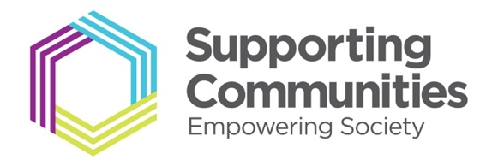
Supporting Communities
Board Member Application Form 2019

Please complete the following information:

- Name
- Address
- Email
- Phone
- Current Job Role and Employer
- Details of Relevant Experience:
- Why do you want to join the Board of Supporting Communities?
(about 250 words or less)
- Please list the expertise and skills you would bring to the board:
- Please list any memberships or positions you hold on other boards, committees or organisations.

