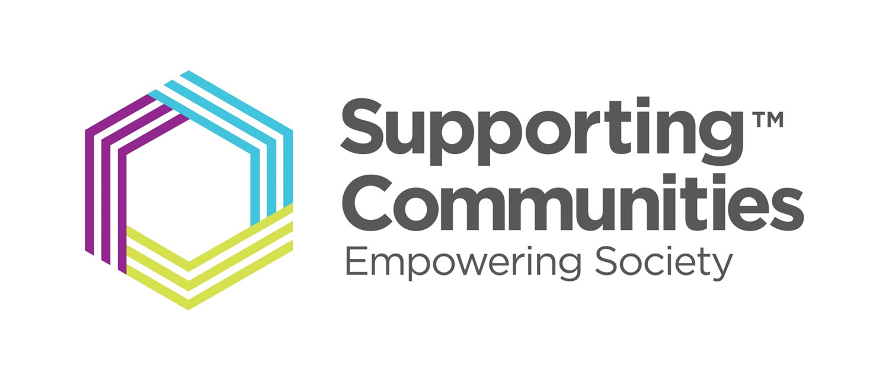

Dear Student,
Supporting Communities is pleased to offer a new scholarship programme for Year 14 (Upper 6th) students in the Ballymena area hoping to attend university in Northern Ireland this September.
The Fund is for Year 14 (upper 6th form) students in Ballymena who are applying to Queens or Ulster University this year to study STEM (Science, Technology, Engineering, Mathematics) or Business-related, including Accountancy degrees. Unfortunately, arts, medicine, health or sports-related degrees cannot be considered for the scholarship.
How much could I get?
If successful, you will receive £2,000 per year of your course up to a maximum of four years. You will also receive a one-off payment of £1,500 at the start of your scholarship support to be spent on IT/Technology equipment related to your studies (a PlayStation 5 does not count!).
Application process
The Scholarship operates a two-tier application process. Firstly, you must complete the online or attached application form and return it, confirming that you meet the criteria. A panel will screen the applications and then invite no more than six students to interview. It is anticipated that the interviews will take place in August 2024 in person in Ballymena. * The two successful applicants will be informed before the start of September 2024. It is important to note that Information given by applicants relating to the essential criteria will be checked for accuracy, and as such, proof may need to be provided by the applicant. By submitting an application, you are confirming that you and your parent(s) / guardian are happy to do so.
Conditions for applications
Applicants must meet all the following conditions:
- Be aged 18+ by or on 30th June 2024
- Are attending one of the following schools as a Year 14 A level student: Ballymena Academy, Cambridge House, Cullybackey College, Dunclug College, Saint Louis Grammar, Saint Patricks College, or Slemish College
- Live permanently at an address in BT42 or BT43 (some addresses in BT44 may be considered)
- Have predicted grades at a minimum of three ‘B’s
- Intend to study at either Ulster University or Queens University commencing September/October 2024
- Intend to study a STEM or Business (including Accounting) related degree
- Do not intend to study an arts, medicine, health or physical fitness-related degree
Applicants must also meet at least one of the following criteria:
- Parent(s) are in receipt of Universal Credit
- Live in social housing (NIHE or Housing Association tenant) or in a recognised social housing area
- Live in a household with a single parent/guardian
- Have a combined household income under £40,000.00 per annum
- Do not live with or are not supported by a parent
How to apply
Applications must be submitted by 5pm on 30th June 2024.
To apply please follow the link below to our online application, scroll to the bottom of the page and click ‘Open Form’ (preferrable method of application).
https://supportingcommunities.org/scholarship-fund
Alternatively, you can complete the application form below and send it to stephen@supportingcommunities.org.
Finally, may I take this opportunity to wish you all the best in your upcoming exams.
Kind Regards
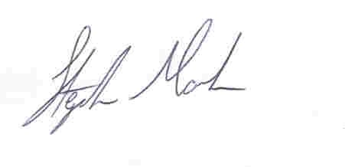
Stephen Marks
P.S. If you have any queries about the process of application, please contact:
Stephen Marks, stephen@supportingcommunities.org

*Subject to any restrictions that may be in place, Supporting Communities reserve the right to carry out interviews via Zoom.
Supporting Communities
SCHOLARSHIP APPLICATION FORM

This application form is for second year A Level student’s (Year 14) preparing to attend University in Northern Ireland i.e., Ulster University or Queens University commencing studies in September/October 2024. Only complete this form if you meet all the criteria in section A below and at least one of the criteria in Section B.

All the information given within this application form will be treated with the strictest confidence in line with the Data Protection Act 2018 and will not be used with any other purpose than that for which it is given. https://supportingcommunities.org/privacy-notice

If you have any queries about the process of application, please contact:
- Stephen Marks, Supporting Communities stephen@supportingcommunities.org

Section A

Please confirm that you meet the following criteria (only students meeting ALL the criteria in this section need apply).

☐ By ticking this box I confirm that I will be aged 18+ by or on 30th June 2024.

☐ I attend one of the following schools as a Year 14 A level student:
Ballymena Academy, Cambridge House, Cullybackey College, Dunclug College, Saint Louis Grammar, Saint Patricks College, Slemish College.

☐ I live permanently at an address in BT42 or BT43. (Some addresses in BT44 will be considered).

☐ My predicted grades are (minimum) three ‘B’s

☐ I intend to study at either Ulster University or Queens University commencing September/October 2022.

☐ I intend to study a STEM or Business (including Accounting) related degree.

☐ I am not intending to study a health or physical fitness related degree.

Section B

Please confirm that you meet at least one of the following criteria (select all that apply)

☐ Parent(s) are in receipt of Universal Credit
☐ I live in social housing (NIHE or Housing Association tenant) or in a recognised social housing area
☐ I live in a household with a single parent/guardian
☐ Combined household income under £40,000.00 per annum
☐ I am not living with or supported by my parent(s)

Applicant Details

Full Name (Mr/Mrs/Miss/Ms):
Home Address:
Postcode:
Telephone Number:
Mobile Number
E-mail:

Current School
University applied to
Degree course applied for
Predicted ‘A’ Level Grades | Subject: Grade:
 | Subject: Grade:
 | Subject: Grade:
 | Subject: Grade:

Educational Background: Please give a brief description of any qualifications you currently have.

Subject Grade

Personal Background: Please tell us about YOU (your interests, hobbies, challenges, and successes.)

Confirmation

By signing this form, I confirm that all information given is accurate and I understand that submission of this form does not constitute an offer of financial support from the related fund or Supporting Communities.

☐ If my application is progressed to the next stage, I will consent to attend an interview.

☐ If successful at interview, I consent to take part in all future fund related / Supporting Communities publications, related to the Scholarship, for marketing/advertising purposes.

Signed: _______________________________________________________

Date: ________________________________

NOTE: Additional information is available on the Supporting Communities website: www.supportingcommunities.org

Please return this application by e-mail to: |  | stephen@supportingcommunities.org
Closing date for applications: | 5pm 30th June 2024
Interviews to be held: August 2024

NOTE: Interviews may be conducted using a digital platform such as Zoom or Teams
Information given by applicants relating to the essential criteria will be checked for accuracy, and as such, proof may need to be provided by the applicant. By submitting this application, you are confirming that you and your parent(s) / guardian are happy to do so.

